Authoritarian Survival and Poverty Traps:

Land Reform in Mexico

Michael Albertus, Alberto Diaz-Cayeros, Beatriz Magaloni, Barry R. Weingast*

March 20, 2015

Why do governments in underdeveloped countries pursue policies that undercut long-term economic growth? Focusing on Mexico's massive but inefficient land reform, we argue that governments do so to underpin political survival. Using a panel dataset of Mexican states from 1917-1992, we find that land distribution was higher during election years and where the threat of rural unrest was greater. Furthermore, PRI support eroded more slowly in states receiving more reform. The inefficient system, carrying restrictive property rights, thus served the PRI regime’s electoral interests. While land distribution generated a loyal political clientele, it generated steep costs – lower long-term economic growth.

* Assistant Professor, Department of Political Science, University of Chicago; Senior Fellow, Center on Democracy, Development and the Rule of Law, Stanford University; Associate Professor, Department of Political Science, Stanford University; and Senior Fellow, Hoover Institution, and Ward C. Krebs Family Professor, Department of Political Science, Stanford University. The authors thank Stephen Haber, Miriam Golden, Emilio Kourí, and workshop participants at Stanford University and UC San Diego for helpful comments.

A general conundrum of government in underdeveloped countries is why political officials pursue policies that prevent long-term economic growth. Governing coalitions in these countries create monopolies and limit economic entry to create rents for favored constituents that distort prices and prevent competitive markets (North, Wallis, and Weingast 2009); create overvalued currencies, allowing the government to allocate scarce foreign exchange to valued constituents or forcing utilities to provide electrical and water service at non-remunerative prices (Easterly 2004); inflate pay for government employees, teachers, and the military in a way that causes budget deficits and reduces future revenue (Bueno de Mesquita et al. 2003); and impose financial market regulations that prevent these markets from financing enterprise creation (Rajan and Zingales 2003).
We address this puzzle in the context of a specific, historically prominent instance: land reform in Mexico. The puzzle is twofold. First, why did land reform in Mexico fail to spur long-term economic growth? Land redistribution in many countries – such as Japan, South Korea, and Taiwan – has catalyzed growth by creating greater equality of holdings (Alesina and Rodrik 1994, Lipton 2009). Second, why did Mexico's land reform have such peculiar properties? Mexico's land reform withheld property titles and created inefficient communal property rights subject to myriad restrictions, including the prohibition of renting, selling, and using land as collateral for loans (de Janvry et al. 2014). Exacerbated by the underprovision of credit and inputs, land reform ultimately trapped peasants into dependence on the state, rather than becoming a major factor underpinning long-term economic development.
Most of the literature emphasizes that Mexico's land redistribution implied a tension between economic growth (capitalist accumulation) and redistribution (social justice) in the countryside; the literature typically attributes the shortcomings of land reform to the failure to make equity and redistribution the overriding policy concern (e.g., Bartra 1993, Ibarra Mendivil 1989, Warman 1972). More recent accounts by economists and policymakers stress the perversity of collective ownership within the ejido, or communal farm (e.g., Muñoz‐Piña et al. 2003). The literature in political science, history, and sociology suggests that land reform was either employed as an instrument of peasant control or regime “legitimation” (e.g., Esteva 1980, Warman 1972).
We build on these works, focusing on why the governing Institutional Revolutionary Party (PRI) structured property rights in an inefficient manner. Mexico specialists have long argued that the PRI used its control of land to sustain its patronage networks (e.g., Simpson 1937, Silva Herzog 1959, Eckstein 1968, Sanderson 1986). Given that the PRI used many other policies to shore up election prospects rather than accomplish their ostensible rationales (Fox 1994, Beer 2003, Hiskey and Bowler 2005), scholars agree that land tenure arrangements in Mexico were inefficient.
This paper provides a more comprehensive examination of the interplay of land reform, development outcomes, and the perpetuation of the PRI in office. Building upon previous scholarship (e.g., Hansen 1971, Gates 1993), we leverage new data to help bring more specificity and nuance to the Mexican case while connecting it more broadly to the study of autocratic regime survival. To understand the structure and consequences of Mexico's land reform program, we model underdevelopment as a function of political survival (e.g., Acemoglu and Robinson 2006, Ames 1987, Migdal 1988). Electoral imperatives and the mobilization of peasants as voters in local and national elections were foundational to the PRI's rule. We argue, contrary to the substantial literature that emphasized the threats and dangers of commercial agriculture, that the lack of markets in the agrarian sector – in particular the absence of credit and land markets – was an essential element of political control used by the PRI to make peasants dependent on the regime by denying them access to independent sources of income. Notwithstanding a programmatic vision grounded in social justice emerging from the Revolution, the PRI leveraged land distribution policies to generate political dependence rather than to empower peasants and enhance their ability to escape poverty via increased agricultural productivity.
Given that the origins of the ejido pre-date the PRI, we do not contend that the PRI initially planned the ejido as an institution to create dependence on the state. The ejido itself stemmed from the model of indigenous rural communities prior to the Ley Lerdo and disentailment with an eye toward self-government, local autonomy, egalitarianism, and inalienable access to land to protect against market or other forms of dispossession (Kourí 2015) – with the major departure that the state rather than local communities would be vested with protecting these rights. Despite considerable struggles over the form it would take during and after the revolution, no alternatives were seriously pursued after the early 1920s. Nonetheless, the ejido underwent key changes, such as Cárdenas’ shift from distributing land as individual plots to each ejido member to collectively distributing land to ejidos as a whole (Otero 1989, 283). Throughout most of the PRI’s tenure and in particular since the end of Cárdenas’ rule in 1940, the PRI took advantage of the initial land reform design and the critical role of the state to starve the ejido sector of the complements it needed to thrive, thereby enabling it to capture rural voters more easily.
To be sure, land distribution aided beneficiaries in the short term and provided an opportunity to remain in the agricultural sector rather than migrating to cities due to land scarcity. These reasons pushed peasants to continue to petition for ejido land from the regime for over 70 years. Yet land reform also carried substantial long-term costs for beneficiaries and for Mexico more broadly. Land recipients came to rely on a flow of federal financial resources and subsidies to survive (i.e., credit, insurance, seeds, and fertilizers). Receiving these subsidies required that the new landholders support those in power, locking peasants into supporting the regime. Furthermore, land reform depressed overall economic growth in the long term by encouraging subsequent generations to stay in the less dynamic rural sector, creating a property rights system that discouraged long-term incentives to invest and produce, and directing resources toward maintaining inefficiencies rather than cultivating self-reinforcing productivity.
We provide systematic empirical evidence for our claims, measuring the magnitude of the effects of land reform on both political support and economic performance and probing the robustness of the results to both model specification and potential endogeneity. First, we estimate the electoral benefits of land redistribution. Our data analysis allows us to estimate two critical values: (i) the number of votes that land reform afforded the PRI; and (ii) the relative pay-off of this policy vis-à-vis promoting economic growth. In the short run, both growth and land distribution had similar effects on PRI support. But land reform had crucial advantages over growth: economic growth and modernization eroded support for the PRI over the long term, whereas land reform generated a loyal political clientele. Second, we show that the economic consequences of the land reform strategy had conflicting effects over time. Land distribution increased state-level economic growth in the short term, whereas the long-term effects of cumulative reform were negative, substantially lowering growth and producing economic stagnation. Finally, we analyze the temporal patterns in land distribution. The PRI distributed land as a function of two political variables: the electoral cycle and the likelihood of rural unrest. This pattern is hard to reconcile with alternative accounts that do not countenance a political objective.
The paper is organized as follows. The next section discusses land reform policies in Mexico, fleshing out our theoretical argument. The following section provides empirical tests of our claims that land reform bolstered the PRI but hindered long-term economic growth. The last section prior to the conclusion discusses land reform from a comparative perspective.

THE ECONOMIC AND POLITICAL LOGICS OF LAND REFORM
Many countries around the world have pursued land reform, and many of these are regarded as highly successful (Lipton 2009). Although the definition of “success” in land reform varies widely, one common benchmark is that reform allows peasants to escape from poverty. If peasants escape poverty, overall agricultural productivity should increase due to greater investment and a more intensive use of labor. This improvement, in turn, increases overall economic performance By this standard, Mexico's land reform has been at best only partly successful. From an economic standpoint, land distribution proved quite inefficient. Scholars broadly agree that Mexican agriculture experienced a steady decline at least since the 1960s (e.g., Lamartine Yates 1981, Sanderson 1986). As we show below, while land reform in Mexico resulted in a modest short-term boost in economic growth, it ultimately undercut long-term growth in the regions where it was most vigorously pursued.

Short-Term Effects of Land Reform
In many countries such as Taiwan, South Korea, and Japan, land reform has furthered both equity and efficiency goals. Land reform often benefits relatively poor peasants (Lipton 2009), and cross-sectional evidence suggests that a more equitable distribution of land is growth enhancing (Alesina and Rodrik 1994). Why should land reform contribute to economic growth? Alesina and Rodrik (1994) suggest that a relatively egalitarian distribution of land is critical for the mobilization of savings and investment that makes economic growth possible. Furthermore, land reform can contribute to agricultural growth given that, all things equal, small farms are often more productive than large farms (e.g. Berry and Cline 1979, Deininger 2003).
The short-term consequences of land reform in Mexico track well with the notion of a welfare boost for peasants and can largely be viewed through the lens of the inverse farm size-productivity relationship. The well-established findings for an inverse farm size-productivity relationship indicate that for a particular plot of land at a particular time, productivity should increase as the plot of land is divided into smaller subunits that are exploited directly by more owners or renters. The logic is straightforward: for smallholders to succeed in the agricultural sector, they must squeeze as much as they can out of their land. Smallholders are also more likely to use part of their land for family consumption, giving them strong and immediate incentives to produce. The value of a marginal hectare of land to a large landowner, by contrast, is much smaller. These landowners can better afford to fallow their land as well as to under-produce when land provides them other benefits: a social return (e.g., higher social status), a hedge against inflation, or simply a country retreat.
This suggests that land reform in Mexico should have boosted short-term economic growth as landless peasants, sharecroppers, and rural wage-laborers came to own land and capture the full marginal product of their labor. It also should have yielded unambiguous support for the PRI among peasants. Upon Porfirio Díaz’s fall in 1911, some 11,000 haciendas held 57% of the national territory (Thiesenhusen 1995, 30). These haciendas, one of the main targets of land reform, were often evolved from Spanish colonial land grants; many produced cattle and crops such as corn and sugar for domestic consumption while exploiting resident peasant labor, whereas others that successfully modernized and capitalized their enterprises turned to export crops such as rubber, coffee, tobacco, and henequen. Together with more traditional haciendas were commercial estates and surveying companies that had appropriated vast swathes of indigenous lands (Thiesenhusen 1995, 33). Some 15 million landless peasants labored for and alongside these enterprises. Land reform boosted their income in the short term, provided employment, served as insurance against infirmity and age, and provided them an opportunity to remain in the agricultural sector rather than migrating to cities due to land scarcity. These benefits motivated peasants to petition for land from the PRI for over seven decades.

The Long-Term Drag of Land Reform on Economic Growth and the Creation of Peasant Dependency

Although land reform won peasant support and spurred economic growth in the short term in Mexico, an alternative logic came to stunt long-term economic growth even while the PRI maintained peasant support. To explain the long-term shortcomings in Mexico's land reform, our argument stresses the perverse incentives faced by an autocratic regime seeking to sustain itself. The mobilization of peasants as voters in local and national elections was a cornerstone of the PRI's rule. Given this electoral imperative, the distribution of land along with the suppression of credit and land markets was an effective tool of political control used by the PRI to tie peasants to the regime by denying them access to independent sources of income; these strategies simultaneously stymied growth. Land distribution was also used as a strategy to undercut the threat of rural instability and maintain a dispersed rural population reliant on the regime. When social unrest and rebellion in the countryside were higher, as during the 1920s-1930s and the 1960s-1970s, the PRI increased land distribution to reestablish rural order and fix peasant communities to the land.
There is an important distinction that must be drawn, however, between the motives and type of land reform pursued from the time of the Mexico Revolution through Cárdenas' rule and the period thereafter. Substantial changes occurred in agrarian policy after Cárdenas left office in 1940. Although there is scholarly contention about Cárdenas' motives, there is agreement that after his tenure credit for fertilizer and other inputs for small farmers and ejidos was drastically cut back, while government support, especially in the form of the construction of irrigation works, went to the large commercial agrarian industrialists of the north—many of whom had been middle class and had risen up the ranks to post-revolutionary leadership positions (e.g., Cockcroft 1983, de Alcántara 1976, Sanderson 1986).
An appropriate model of the political economy of Mexico’s development must explain the form of restrictions imposed by post-revolutionary regimes on land distributed by the state, and why Mexico’s land reform had only a fleeting positive effect on economic growth. Land reform in Mexico was characterized by the following features:
- Land was granted to groups, not to individuals;
- Land distribution was a permanent process: it continued for decades (Prosterman and Riedinger 1987);

- Land could not be legally sold, rented, or used for collateral (de Janvry, Gordillo and Sadoulet 1997);

- The president was directly in charge of the distribution of land, as petitioned by peasants through the state governors and the National Agrarian Commission (Walsh Sanderson 1984);
- As land reform continued, a parallel private property regime for land rights was developed, which was invulnerable to expropriation by the state for the purposes of land redistribution.

Many accounts have highlighted these characteristics of land reform in Mexico. However, few accounts explain why land reform had these specific characteristics or precisely how they were tied to key outcomes such as PRI support and economic growth. Our theory of land reform draws on an approach to the political economy of development whereby the party in power can obtain electoral support either by promoting economic growth or by creating a “punishment regime” in which it uses its fiscal resources to induce political support by rewarding supporters and punishing opponents (e.g., Ames 1987, Migdal 1988). Voters must decide how to vote knowing that defectors may be punished by the withdrawal of government transfers.
This approach yields several insights. First, the poorer voters are, the more effective is the punishment regime in deterring voter defection. A fixed subsidy is more likely to sway a poor voter than a richer one. Second, the growth-promoting strategy has a serious disadvantage because it is self-defeating over time. Growth garners short-run political support because it makes voters better off in that period. Yet the richer voters become, the more able they are to defect from the system (e.g., Magaloni 2006). The policy perversity arises because the PRI based its long-term support on a critical mass of poorer voters whose dependency on the state was crucial to maintaining support. Whereas the PRI therefore had short-term incentives to deliver economic growth, consistent growth ultimately undercut their grip on power by enabling wealthier voters to defect from supporting the regime while still maintaining their livelihood.
The Mexican land distribution arrangement created a complex system that granted land to peasants in exchange for their political loyalty. Land was granted to a village as a whole, with individuals named as beneficiaries. Peasants acquired the right to use and work the land either individually or collectively, but were not granted full property rights. Peasants were not permitted to leave their plots idle for more than two consecutive years, and were not allowed to rent individualized plots. If peasants migrated to the cities or to the U.S., they risked losing their land, which provided incentives to remain in the countryside where the PRI had greater leverage over them. This prevented markets from arising that would allow land to be transferred to the highest valued users (e.g., Lipton 2009). Furthermore, before the end of land reform in 1992, neither the village nor individual peasants could sell the land or use it as collateral to access commercial loans. Given that such common property restrictions typically engender a dearth of privately provided credit (e.g., Rajan and Zingales 2003), peasants depended upon the state's credits for their livelihood (Otero 1989). The agrarian federal bureaucracies, controlled by the PRI, could threaten the denial of credits if peasants failed to support the party.
Collective ownership meant that investment and improvements to land could occur only with direct state aid, primarily through official petitions, rather than pursued by peasants as private enterprises. Furthermore, the value of the investments and improvements could not be appropriated by individual farmers, creating problems of moral hazard – a phenomenon well documented in the literature on property rights (e.g., Ostrom 1990). In combination, these two effects encouraged the undercapitalization of land even in those ejidos with access to credit. Peasants came to rely on state subsidies and credits for seeds, insurance, fertilizer, and other inputs to produce.
State subsidies and credits provided the PRI with a credible threat over local agricultural communities: failing to support the PRI in elections risked losing the subsidies needed to survive. If peasants and other opposition groups could have coordinated, they could have attempted voting out the PRI or pressuring for more autonomous peasant unions and distribution networks that would fix these shortcomings. But this type of coordination is difficult, especially in rural areas where populations are dispersed and relatively immobile. One peasant community, acting on its own, cannot affect the system but only whether it receives its subsidies. This scenario forces each peasant community to toe the party line. Indeed, as latent pressure from below became manifest in frequent rural rebellions in the 1960s and 1970s that threatened a more coherent challenge to political stability, the PRI responded with increased land distribution to reestablish rural order and keep peasant communities involved in production.
This relationship of dependency became ever more consequential for economic growth with the introduction of new technology (e.g., mechanization) that increased the value of land for agricultural production. While private and larger farms could quickly take advantage of these changes, ejidos were forced to rely on the state, which had incentives for them to limp along but never quite become independent. The nature of ejido communities only compounded these problems. As ejido membership grew over generations, communal land was subdivided into smaller and smaller plots. This led to overexploitation and depleted soils, which stunted agricultural productivity and made ejidos even more reliant upon inputs from the PRI.
Land reform legislation evolved over time, especially after Cárdenas’ rule, to seize on these characteristics and increase the political utility of land reform as the early stages of reform gave way to continuous, decades-long reform under the PRI. Table 1 details key developments in the evolution of land reform legislation. It highlights how land policy gradually became centralized as the state developed and the PRI consolidated, how mechanisms of legal protection became increasingly weak, and how tension mounted between economic growth and keeping land reform policy alive. As PRI governments realized the deleterious long-term economic effects of their land reform policy on the agricultural productivity that was key to providing cheap food to potentially volatile urban workers, they created a parallel system of property rights that provided immunity from land redistribution while keeping the ejido system intact.
Although some evidence suggests that the ejido system was initially not inferior to private cultivation (Eckstein 1968, Otero 1989), consistent with the short-term burst in productivity and growth in the early years of land redistribution, it eventually led to poor incentives for production, particularly as more low quality land was distributed. Lamartine Yates (1981,134) calculated that by 1970 crop output per hectare was around 40% higher in small private farms than in the established ejido sector. This was not a predetermined outcome: land redistribution combined with greater support in terms of quality education in rural areas, adequate technical support, and subsidized credit may have produced more sustainable economic growth (de Alcántara 1976, Otero 1989).

EMPIRICAL EVIDENCE: LAND DISTRIBUTION, ELECTORAL IMPERATIVES AND ECONOMIC GROWTH

This section provides empirical evidence regarding the political manipulation of land distribution and its consequences. First, we study the relationship between land distribution and the erosion of state-level PRI support. Second, we study the short- and long-run consequences of land reform for economic growth. Finally, we investigate land reform timing.

Electoral Decline and Permanent Land Distribution
To test our argument that land distribution helped the electoral fortunes of the PRI, we examine the determinants of PRI support in each Mexican state in the post-Cárdenas period from 1940-1994. Mexican specialists have noted, at least since Brandenburg (1955), that PRI support varies across states in significant ways. We test directly whether land distribution reduced the erosion of PRI support over time and show that land distribution improved electoral support for the PRI, controlling for wealth, economic growth, and urbanization.
Several models in the analysis include state fixed effects, which implicitly control for unobserved state-specific and time-invariant heterogeneity (e.g., geography, proportion of arable land, or political culture) that may jointly influence a state's support for the PRI and the degree of land reform. If a variable remains relatively constant over time, its omission will not bias our estimates in these models. Most estimations also include a time trend to capture the secular decline in support for the PRI over time. The time trend is specified as the log of the count of presidential administrations given that PRI support eroded slowly at first and then more quickly with time. Including this trend ensures that the estimated impact of land distribution on PRI support does not simply proxy for a secular shift that is due to other factors such as opinions about the party's legitimacy or national-level electoral irregularities or vote rigging.
To address potential issues of heteroskedasticity and any arbitrary patterns of correlation within countries, such as serial correlation and correlation due to state-specific components, we cluster standard errors by state. Lastly, we lag the independent variables by one period so that they capture processes occurring temporally prior to an election and thus capture voter responses.
The dependent variable is measured as the state-level PRI vote share by presidential election. Data on PRI vote share are taken from Castellanos Hernández (1997). The mean PRI vote share by presidential election during the period was 0.824, or 82.4%. Table 2 contains a full set of summary statistics for this and other variables used in the analyses.
As with numerous authors (e.g., Kurtz 2004, Magaloni 2006), we use PRI vote share data to analyze voter support for the party. Nonetheless, these data should be treated with caution. As Klesner and Lawson (2001, 24) summarize, it is well known that "the PRI long engaged in any manner of fraud to increase its vote shares at the expense of the opposition." PRI vote share may therefore capture not only genuine voter support, including support generated clientelistically through policies such as land reform, but also the local capacity of the PRI to rig elections. Of course, to the extent that these are effectively random noise or uncorrelated with land reform, they should simply bias downward the estimated coefficients and make a relationship harder to find. The models address more serious concerns with rigging not only by including state fixed effects and a time trend, but also by testing robustness to state-specific time trends. For fabrication to be problematic in the fixed effects models with state-specific time trends, it would have to be quite particular: state-level and time-varying in a way that deviates from within-state trends in PRI support and is systematically positively correlated with observed land distribution. We are unaware of any literature suggesting this specific pattern of tampering.
The key independent variable in the analysis is land distribution. Land distribution is measured in two different ways, with data constructed from the Padrón e Historial de Núcleos Agrarios of the Registro Agrario Nacional. The first measure, Land Distribution (% Area), captures the percentage of total surface area in a state distributed to peasants under a given administration. This variable reflects the change in each administration of land that is either owned by private landholders or the federal government and that is turned into ejido land. The average of this variable was 2.83%. Because this measure is normalized by state land area and the demand for remaining unreformed land may have potentially shifted by administration in a way that made further transfers more or less important, we also include a second measure of land reform that captures the log of total land area transferred in hectares. Consistent with the theory detailed above, we expect both land reform measures to have a positive effect on PRI support.
The analysis also includes a set of control variables hypothesized to affect PRI support over time. The first measures the level of development in each state for a given administration, defined as the log per capita GDP in constant 1993 pesos. State-level GDP data are from Germán-Soto (2005), and population data are from the national statistics agency (INEGI). Following Molinar (1991) and Magaloni (2006), we expect the level of development to diminish PRI support. Richer voters can better afford to make “ideological investments” in democratization and defect from the PRI despite risking financial punishment (Magaloni 2006).
The analysis includes a variable for economic growth, measured as the growth rate of state GDP across administrations. Mexican political observers have long claimed that one reason why the party persisted during the “Mexican miracle” was due to its delivery of economic growth. Our theoretical framework highlights that economic growth has conflicting effects on autocratic survival: while we anticipate economic growth to have a positive short-term effect on PRI electoral support, a higher level of development should hurt the PRI. Data on state-level economic growth were calculated from the state GDP data from Germán-Soto (2005).
Our models also include a measure of urbanization, with data taken from INEGI census data. Percent Urban is measured as percentage of the population living in urban areas. We adjust the scale of this variable for the tables by dividing by 100; it can therefore be interpreted as the proportion of urban residents in a state. Consistent with Brandenburg (1955), we expect this variable to have a negative effect: more urban states should support the PRI at lower rates.
Finally, we tried controlling for financial transfers in the form of federal public investment. Although he failed to reach conclusive results, Ames (1970) tested the hypothesis that higher levels of federal public investment should increase PRI support. Federal Public Investment is measured as a percentage of state GDP and is taken from Arroyo (1995). Data are only available beginning in 1958.
Table 3 reports the estimates of PRI support beginning in the 1940s. Model 1 indicates that, as expected, high levels of GDP per capita erode PRI support. By contrast, economic growth as reflected by Δlog(GDP) brings greater support to the party. Controlling for the effects of economic modernization on political support, the distribution of land as measured by Land Distribution (% Area) increases PRI support in the states. Finally, as anticipated, higher rates of urbanization are linked to lower rates of PRI support.
Model 2 includes the measure of federal public investment. Though positive, it is far from statistically significant. Because including this variable also substantially reduces the overall number of observations in the model by truncating the sample to post-1958, it is excluded from remaining models.
Models 3-4 introduce a time trend. The estimated effect of land distribution on PRI support is again strongly positive, whether measured as Land Distribution (% Area) or log(Land Distribution). GDP per capita maintains its sign but loses statistical significance in these models. It regains significance, however, with the inclusion of state fixed effects in Models 5-6.
Land distribution has a positive and statistically significant effect on PRI support in Model 5. The size of the effect is meaningful: if 10% of the land in any given state is distributed, PRI votes increase by roughly 3.8 percentage points. Using the variable log(Land Distribution), a two standard deviation in land distribution above its mean results in a predicted 3.6% increase in PRI support using the Model 6 coefficient. However, this variable does not reach conventional levels of statistical significance in Model 6 (p=0.19).
The negative effect of higher GDP per capita on PRI support is relatively strong in Models 5-6. An increase in GDP per capita of 50% leads to an approximately 9.6% drop in PRI support. By contrast, economic growth as reflected by Δlog(GDP) brings greater party support. The average state-level economic growth across six-year administrations (32.8%) yields roughly 11% higher PRI support. At that growth rate, the net effect of modernization on PRI support becomes negative after three presidential administrations, or a total of 18 years, and subsequently continues to decline. The declining positive effects of growth on PRI support are compounded by the fact that growth tends to slow at higher levels of development (Barro and Sala-i-Martin 1995), eroding the capacity for growth to gain party support. As expected, therefore, the results indicate that growth has conflicting effects on PRI support.
Urbanization has a negative effect on changes in PRI support across the Table 3 models, leading to a decrease in PRI support. A 10% increase in the percentage of the population that is urban in a state leads to an estimated 5.9% decline in PRI support in Models 5-6.
Figure 1 shows the Model 5 estimated effects of three key independent variables on the change in PRI support: the level of development, economic growth, and land distribution (% Area). The predicted values are calculated keeping all other variables at their means. While the variables graphed in Figure 1 have different scales, they are graphed together here as if they were in an analogous scale. Each variable is graphed from its minimum to its maximum values.
Figure 1 provides several insights. First, consider land policy. The land distribution variable ranges from 0% of land area in a given state distributed by a specific administration to 58% of the land area being distributed (corresponding to Baja California during the Díaz Ordaz term). The positive slope of the line for land distribution suggests that distributing ejido land generated greater support for the PRI.
Second, consider state economic growth. The dotted line is also upward sloping, indicating that growth enhanced the PRI’s political prospects. Although accumulating economic growth ultimately led to a decrease of PRI support as states got richer, as indicated above, growth itself had a positive effect on PRI support. At the lowest end of observed growth rates, the first percentile growth rate in a Mexican state over the course of a presidential administration during this period was -32% (a yearly average of -5.3%). Ceteris paribus, a growth rate of this magnitude results in a predicted 57% electoral support. But a yearly growth rate of 14.7% (a total of 88% during an administration) in an otherwise similar state, which corresponds to the 99th percentile in this data, produces an estimated slightly over 97% support level for the PRI.
While growth and land distribution had positive electoral effects for the PRI, land reform had crucial political advantages: land distribution was more fully in the scope of government action, and in contrast to growth, which was destabilizing over time, land was used to maintain a political clientele loyal. Figure 1 shows that the level of development lowers PRI support. Only very poor states are predicted to maintain their support for the PRI due to this variable. The estimates provide a clear picture of the way in which modernization eroded hegemony. Until the mid-1960s, the low per capita GDP of many states predicts that poor regions confer substantial support to the PRI during presidential elections. However, over time, accumulating economic growth led to a decrease of PRI support as states got richer. Combining the two effects we estimate that, by the mid-1980s, the poorest states such as Oaxaca and Chiapas were among the few predicted to maintain high levels of support for the PRI across elections.
Robustness to Lags and State-Specific Time Trends
The theoretical argument indicates that peasant capture, once it occurs, is persistent. Model 7 tests this hypothesis more explicitly. Model 7 also more directly models persistence and feedback in PRI vote share. It does so by using an autoregressive distributive lag (ADL) model. The dependent variable is now the change in PRI vote share across administrations, and the ADL model adds a lag of the dependent variable and a lag of Land Distribution to the regression. This strategy enables us to calculate the total, long-run effect of a permanent change in Land Distribution. The long-run multiplier (LRM) coefficient is 0.268 (p<.05), supporting the notion of long-term peasant capture. Meanwhile, the lag in PRI support is statistically insignificant.
Model 8 attempts a different approach at modeling short- and longer-run effects. Since GDP per capita in levels may capture more than just the sum of changes in economic growth, Model 8 drops GDP per capita. It then adds additional lags of Land Distribution and Δlog(GDP), and interactions between these variables and their lags. Land Distribution and its lag are both positive and statistically significant whereas Land Distribution interacted with its lag is insignificant. This again suggests that peasant capture is persistent across periods, and additional land redistribution on top of previous land redistribution has no deleterious effect on PRI support. While Δlog(GDP) and its lag are similarly both positive, Δlog(GDP) interacted with its lag is now negative and statistically significant. While economic growth contributed to PRI support, sustained positive growth that yielded higher levels of development undercut the PRI.
Model 9 drops the national-level non-linear time trends in favor of state-specific time trends. States differ considerably, and there may be systematic trends in PRI support that differ across states in a way that is correlated with land reform but due to omitted or unobserved policy instruments or other factors such as the capacity to rig elections. Including state-specific time trends alleviates these concerns and others for which national-level trends only imperfectly capture state-level drifts. The Model 9 results confirm the findings from previous models.
Robustness to Endogeneity
While Table 3 suggests that land distribution yielded higher PRI support, there may be reverse causality running from PRI support to land distribution that biases the estimated coefficients. For example, states with a history of high support for the PRI may be more likely to receive land via the land reform program as a reward for political loyalty. Without doubt, states that "underprovided" support to the PRI – like Guanajuato and Jalisco – received less land. We therefore turn to an instrumental variables (IV) approach designed to capture exogenous variation in land distribution.
We instrument land distribution with the number of land beneficiaries (in thousands) in a state's surrounding region and the number of hectares (in millions) of arid land in the state. Beneficiaries in the surrounding region, who have on average had their land applications in for at least seven years prior to receiving grants, should affect PRI support in a state by increasing the likelihood of land distribution due to regional pressure or demonstration effects stemming from peasants requesting more land. The second instrument, Arid Land Area, should also be linked to higher land distribution. Because arid land is lower quality due to exogenous climatic and geographic factors, a greater portion of arid land in a state led to larger land grants in those zones. Similarly, the PRI was more willing to distribute tracts of arid land that were of lesser value once more productive lands had been distributed (Walsh Sanderson 1984).
Do these instruments satisfy the exclusion restriction, or might they proxy for or be correlated with some factor that exerts a direct effect on PRI support? Perhaps a lack of land reform (and beneficiaries) in neighboring regions of a given state may spur immigration to that state in hopes of benefitting from more reform there, and also consequently be tied to increased support for the PRI. To address this particular threat to inference, the Table 4 models all include Net Migration, which taps state migration inflows and outflows. Data for Net Migration migration in millions of people are calculated from census figures and taken primarily from INEGI. Alternatively, more land reform beneficiaries in a state's neighborhood may affect PRI support by influencing voters' perception of the PRI's commitment to redistribution. We thus also tried controlling for the average regional change in PRI support in the previous period to pick up the potential spillover in voter perception associated with neighboring land reform, with very similar results. Beyond this, we conducted statistical tests of the overidentifying restrictions and consistently fail to reject the hypothesis that the instruments are valid.
Nonetheless, it is worth underscoring that while we have attempted to eliminate threats to inference from any foreseen potential violations of the exclusion restriction, selection into land reform could still be driven by unobserved factors. As with any instrumental variables analysis, this would be problematic if these factors were linked to the outcome variable and instruments.
Table 4 presents the second-stage IV results. Models 1-2 use region rather than state fixed effects given that arid land area is fixed by state. While the full first-stage regressions are omitted for space reasons, the coefficients on the instruments in the first stage are reported in Columns 1-2. The results conform to theoretical expectations: Beneficiaries in the Region is positive and highly statistically significant, and Arid Land Area is also positive (and statistically significant in Model 2). The results from the first stage also suggest that these variables are good instruments from a statistical perspective. The F-statistic is 17.12 in the first stage of Model 1 and 20.45 in Model 2 – above the threshold separating weak from strong instruments. Importantly, heteroskedasticity and autocorrelation consistent Hansen J tests of the over-identifying restrictions fail to reject the hypothesis that these instrumental variables are exogenous.
The second-stage results in Models 1-2 demonstrate that the findings for land distribution from previous columns hold: Land Distribution (% Area) and log(Land Distribution) are positive and strongly significant.
Models 3-4 present a second set of IV regressions. These models reintroduce state-level fixed effects. Arid Land Area therefore drops from the first stage. Beneficiaries in the Region remains strong in the first stage. Furthermore, the coefficients on Land Distribution (% Area) and log(Land Distribution) are positive, strongly significant, and similar in magnitude to the Model 1-2 coefficients. If 10% of the land in a state is distributed, PRI votes increase by roughly 13.3 percentage points. The variables for modernization and urbanization are statistically significant and in the same direction as previous models.
Models 5-6 replace the national-level time trend in Models 3-4 with state-specific time trends similar to Model 9 of Table 3. Again the main results for land distribution and modernization hold.
The substantive significance of the IV coefficients for Land Distribution (% Area) and log(Land Distribution) in Table 4 increases notably vis-à-vis both the Table 3 models and the modernization variables. Because the Hansen J tests indicate that the instruments are valid, the measures of land distribution are most likely endogenous, and the direction of bias is apparently against our hypothesis barring serious violations to the validity of our instruments. Accounting for potential sources of endogeneity implicitly in the IV framework yields a more accurate estimate of the true impact of land distribution on PRI support.
The Table 3-4 results emphasize the conundrum for the party: because development undermined its support, how could it remain in power? The best option for the PRI, according to these results, is that a state grows while remaining underdeveloped. But such combination is impossible, because in the long run states growing faster become richer, and thus would abandon the party. To the extent that the regime could use its power and policies such as land reform to garner political support separately from growth, it could delay the negative political consequences of modernization.

The Economic Consequences Of Land Reform: A Short-Term Increase in Growth Followed by a Long-Term Decline

Mexico arrived to the developmental scene of the post-WWII years as a promising example of a progressive government that had achieved land reform where other countries throughout Latin America had failed. Compared to other countries in the world, Mexico had a moderate level of land concentration in 1960: similar to that of the United States and Britain and substantially lower than most other Latin American countries such as Argentina, Brazil, Colombia, Guatemala, and Peru.
Yet why did Mexican land reform fail to translate into superior Mexican growth vis-à-vis even its Latin American peers, let alone those countries where land reform was implemented heavily such as India, Japan, South Korea, Taiwan, and China (following the agrarian reforms of the late 1970s)? This section demonstrates that while land reform in Mexico led to short-term economic growth, over time its effects on growth became negative.
We employ standard empirical growth models to understand the effect of land reform on development. Several models include state fixed effects to control for unobserved time-invariant factors such as geography, culture, state land area, or the initial stock of land available for reform that could otherwise affect both economic growth and land reform. The estimations also all include linear, quadratic, and cubic time trends. Land reform declined from 1940 into the 1950s followed by an increase through the late 1960s and early 1970s and finally a decline throughout the 1980s until the end of land reform. If these trends are correlated with economic growth, failing to include time trends may result in attributing a causal role to the impact of land reform on growth that instead reflects secular shifts due to other factors.
Our dependent variable is the yearly economic growth of Mexican states from 1940-1992. The mean level of growth during the period was 5.51%. Following standard models, we employ two independent variables to account for initial levels of development and human capital (Barro and Sala-i-Martin 1995). The first is log per capita income. The second variable captures the percentage of the population over age ten that is illiterate, with data from INEGI. As the growth literature details extensively (e.g., Barro and Sala-i-Martin 1995, Ch. 11-12), poor states tend to grow faster than richer ones. Hence, convergence hypothesizes a negative relationship between per capita income and long-term growth. On the other hand, human capital should speed up convergence, with higher literacy rates linked to greater economic growth. Illiteracy Rate should therefore have a negative sign.
We include two main variables for land reform. The first measure, Land Distribution, captures the log of total land area transferred in hectares in the previous five years. This variable uses a five-year window of reform given that the true impact of land reform on short-term growth elapses over several years as new ejidos are organized and begin production. This variable also smoothes the uneven nature of land distribution in any given year, capturing more coherent policies of distribution in a given state over a period of time. The second land reform variable, Cumulative Land Distribution, measures the log of total land area transferred in hectares from 1917 up until the beginning of the five-year window recorded by the Land Distribution variable. Cumulative Land Distribution therefore taps the longer-term impact of a history of land distribution on economic growth. The average of the unlogged version of this variable is 1.8 million hectares. Consistent with the theory detailed above, we expect land to have a positive effect in the short term followed by a negative long-term impact.
We also include Percent Urban given that the effect of land reform on growth may simply capture the pace of rural-urban transformation, which when more rapid may contribute to growth through, inter alia, an increase in the manufacturing labor supply. Furthermore, we include Net Migration given that state migration inflows and outflows may be linked to new land distribution and simultaneously have implications for economic growth.
Table 5 reports a series of OLS estimates of economic growth. Model 2 adds Net Migration to the Model 1 baseline, and Model 3 adds state fixed effects. The central variables of interest, Land Distribution and Cumulative Land Distribution, have conflicting effects on growth. Land distribution in the previous five-year period has a positive impact on growth in Models 1-3. The yearly effect is rather small: ceteris paribus, a one standard deviation increase in land distributed yields a 0.084% increase in yearly growth in Model 3 specification. The cumulative effect of land distribution, however, is negative and statistically significant in Models 1-3. A one standard deviation increase in prior land distributed yields a 0.122% decrease in yearly growth in Model 3.
The variables for per capita income and illiteracy in Models 1-3 suggest conditional convergence and a positive effect of human capital formation, consistent with previous findings. Model 3 indicates that the growth of a rich state with double the income per capita of a poor state should have a lower economic growth rate than the poorer state by roughly 9%. The speed of convergence during this period is fast, consistent with the literature on growth in Mexico.
Robustness to Lags and State-Specific Time Trends
Model 4 substitutes the Cumulative Land Distribution measure with lags of previous 10-year windows of land redistribution. Because the cumulative measure increases over time by construction, if growth rates trend down as incomes rise, the negative result in Models 1-3 may be spurious. To test this, Model 4 includes 5-year and 15-year lags of land distribution in addition to the five-year window of recent land distribution in Models 1-3. Land Distribution in the previous five-year period has a positive impact on growth. Land Distribution in the prior ten years has a negative but insignificant effect on growth, and Land Distribution ten more years previous (i.e., 15-25 years prior to the present) has a negative and statistically significant effect. Confirming previous models, Model 4 therefore indicates that land distribution has a positive short-term influence on growth that slowly turns negative in the long term.
Model 5 returns to the Model 3 specification but drops the national-level non-linear time trends, instead including state-specific time trends as in Table 3, Model 9. The results strengthen. Systematic trends in economic growth driven by unobserved policies or factors that differ across states and may be correlated with recent or cumulative land reform are not driving the findings.
Robustness to Endogeneity
Of course, the size and direction of the estimated effects of land distribution on growth may suffer endogeneity bias related to the possibility that economic growth may in part cause land distribution. For instance, high rates of economic growth in a state may spur demands from below for distribution of wealth and property. Or perhaps states with low rates of growth may be targeted with land reform as demands for land fester and the threat of rural unrest increases. We therefore turn to a series of instrumental variables estimations in Models 6-9 that build from Model 3.
We conduct the IV estimations with instruments for both Land Distribution (5 yr) and Cumulative Land Distribution. As in Table 4, we use the number of land beneficiaries in a state's surrounding region and arid land area as instruments for the 5-year lagged sum of Land Distribution. We also use two instruments for Cumulative Land Distribution. The first is the cumulative number of beneficiaries (in millions since 1917) in the surrounding region, since this should increase cumulative land distribution in that state due to local pressure and demonstration effects. The second instrument is Percent Mountainous Land. In contrast to rain-fed zones, pasture and rangeland, the most rugged, rural mountain zones (e.g., the northern Sierra Madre Oriente) were more difficult to distribute in large tracts (Walsh Sanderson 1984). States with more mountainous land should consequently have had less cumulative land distribution.
There are several potential threats to the exclusion restriction that could be raised. First, more neighboring land reform beneficiaries may directly suppress growth in a state if growth rates are spatially correlated (perhaps due to other policy instruments or shared markets). Controlling for a spatial lag of growth, however, did not alter the results. The percentage of mountainous land may also directly influence growth through health and infrastructure provision, or alternatively through impacting agricultural productivity. Again, controlling for these factors did not change the results. Furthermore, statistical tests of the overidentifying restrictions always fail to reject the hypothesis that the instruments are valid.
Models 6-7 of Table 5 present a set of second-stage IV estimations. Model 6 uses region rather than state fixed effects since arid land area and percent mountainous land are fixed by state. The first-stage results, omitted for space considerations, are as expected: Beneficiaries in the Region is positive and highly statistically significant in the first stage where Land Distribution (5 yr) is the dependent variable (Models 6-7), as is Arid Land Area (Model 6). Cumulative Beneficiaries in the Region is also positive and highly statistically significant in the first stage where Cumulative Land Distribution is the dependent variable (Models 6-7), and Percent Mountainous Land is negative and statistically significant (Model 6). The first-stage F-statistics consistently indicate strong instruments, and a Hansen J test of the over-identifying restrictions fails to reject the hypothesis that the instrumental variables are exogenous.
The second-stage results in Models 6-7 suggest that the true effect of land distribution on economic growth is higher after addressing possible endogeneity. The yearly effect of a one standard deviation increase in the 5-year sum of Land Distribution is now a 0.99% increase in growth using the Model 7 coefficient. If this impact is compounded over a five-year period, growth increases by slightly over 5%. The cumulative effect of land distribution, however, remains negative and increases in magnitude over Models 1-3. A one standard deviation increase in prior land distributed yields a 1.02% decrease in yearly growth.
The impact of these differing effects becomes substantial as land distribution cumulates, increasing the cumulative measure relative to the 5-year sum. If all states experienced the average yearly values in the dataset for the 5-year window of Land Distribution and for Cumulative Land Distribution, the average estimated growth rate using the Model 5 coefficients would have been 3.88% per year. If land distribution had been 30% less than it was, however, the average estimated yearly growth rate would have been 6.61%.
Robustness to Agricultural Sector Weight
Models 8-9 replicate Models 6-7 but now weight the measures of land transferred with a measure of the fraction of state GDP that derives from agriculture. These models help account for potentially time-varying effects of land transfers on economic growth that track with the size of a state's agricultural sector relative to state GDP, though the effects of land reform on growth need not be restricted to the rural sector (see, e.g., Lipton 2009). The main results strengthen in magnitude and remain statistically significant, perhaps unsurprisingly given that land reform should have a bigger impact on growth where agriculture plays a bigger role in total GDP.

The Timing of Land Distribution: The Electoral Cycle
Land reform in Mexico became a permanent fixture of the regime’s policies from the last years of the Mexican Revolution until 1992 (Prosterman and Riedinger 1987). Figure 2 shows land distributed by definitive presidential decrees in Mexico from 1917-1992. The most intense episodes of land grants occurred in the 1930s-early 1940s and in the late 1960s-early 1970s. The Lázaro Cárdenas administration distributed around 9.6% of the total land area in the country; the Díaz Ordaz administration distributed 12.6%; and Echeverría distributed around 5.5%. By 1990 more than half of the national territory had been distributed.
From 1917-1992 the Mexican government distributed an average of 1.3 million hectares of land each year. Many scholars have attributed this trend to bureaucratic inertia within the "revolutionary state" (e.g., Grindle 1986) or to presidential ideological commitments to land distribution (Wilkie 1978). Scholars have well documented, for instance, that the Cárdenas administration used land reform as a crucial mechanism to reconstruct his reformist political coalition (e.g., Cornelius 1975). However, the literature on land reform in Mexico is less clear as to why the Díaz Ordaz administration reactivated such massive land reform. The ideological commitment to land distribution is not a good explanation, since by virtually every account Díaz Ordaz was a heavy-handed “law and order” conservative politician. His successor, Luis Echeverría, who by all accounts was a leftist and populist leader, did not distribute land more intensely than other presidents.
Our theoretical discussion suggests why Díaz Ordaz accelerated land reform. To survive, the PRI had to both staunch the erosion of their support and avert the risk of instability. The 1960s were a time of electoral and social challenges. By the late 1960s the PRI was facing increasing opposition to its hegemony, including the loss of one gubernatorial election (Nayarit), and most likely fraudulent victories in several state elections (Chihuahua, San Luis Potosí and Sonora) and municipal races (Bezdek 1973). Erosion of the PRI’s electoral support was accompanied by social unrest, culminating with the violent repression of the student movement in 1968, which revealed the regime's more authoritarian side. The PRI rarely resorted to violence if it could achieve political support through other means. The social unrest, guerilla activity, and frequent rebellions in the countryside in the 1960s and early 1970s therefore made land distribution attractive as a strategy to undercut instability while avoiding the use of force.
To gain insight into the timing and targeting of land reform, we perform a series of tobit and OLS estimations of land reform from 1930-1992 using the state-year as the unit of observation. The tobit models include region fixed effects and the OLS models include state fixed effects to control for unobserved heterogeneity and time-invariant factors linked to land distribution such as soil quality, climate, land area, terrain, and land arability. The estimations also include linear, quadratic, and cubic time trends given that land distribution was high in the 1930s, declined from 1940 into the 1950s, increased through the late 1960s and early 1970s and finally declined throughout the 1980s until the end of land reform. The time trends capture secular trends in land distribution due to factors such as ideological commitments to land reform, presidential priorities, or the nature of the political challenges that faced the regime. We cluster standards errors by state to address potential issues of heteroskedasticity and autocorrelation due to factors such as bureaucratic inertia in land distribution.
The dependent variable is the log of total land area transferred in hectares. To measure the impact of electoral challenges we include a dummy variable, Election, for election years. We subsequently separate this variable into two dummy variables: Presidential Election and Midterm Election. Both presidential and midterm elections occurred every six years during the period, and were offset by three years. To examine the influence of rural unrest we include a proxy for latent pressure from below by rural workers, measured as the log of the net value of agricultural, animal and forest production in constant 1970 pesos divided by the number of rural inhabitants. Agricultural production data are constructed from agrarian censuses. This composite measure should be lower when the amount of land and the value of agriculture are high relative to rural population size. We invert this measure so that higher values correspond to greater latent land pressure. This measure has the advantage that it captures the likelihood of rural unrest rather than outright rebellion, the latter of which was typically met with repression whereas the former could be addressed by the PRI via higher land distribution to forestall revolt.
The analyses also include several controls. We employ a variable that simply measures the log net value of agricultural, animal and forest production in constant 1970 pesos. Agricultural value may affect land distribution by enabling the appropriation of future surplus via reform. We also include a variable for rural population density to control for demographic pressure driving the pace of reform.
The analyses, reported in Table 6, suggest that land reform responded primarily to the electoral calendar and latent pressure from below by rural inhabitants. These variables are positive and statistically significant across Models 1-7, indicating that they are robust to model specification, introducing time trends, and including region or state fixed effects. The coefficients on elections in the tobit models indicate that about 26% more land, or nearly half a million additional hectares, was distributed in electoral years than in non-electoral years.
The existence of a strong “political cycle” in land redistribution is hard to reconcile with alternative explanations that do not imply a political objective. Indeed, as Models 5 and 7 indicate, the spike in land distribution around elections also occurred during midterm elections. The link between presidential elections and land distribution cannot therefore be explained by the president seeking to accomplish land distribution goals in the twilight of his term. The electoral imperative of generating voter support provides a more plausible explanation. No PRI president wanted to be the one who led to a weak election for his successor or presided over substantial midterm election losses, so no PRI president wanted to halt land reform.
The Table 6 models also indicate that land reform was used as a tool to avert the risk of instability. Land distribution increased when the value of agricultural production was lower relative to the number of rural inhabitants. This is particularly notable during the two main spikes of land reform seen in Figure 2. The Cristero war spread in the late 1920s as rebels launched operations from rural bases, and rural militias (agraristas) were recruited to resist them in areas where federal troops were absent until their 1936 pacification. The conflict also caused disruptions in production in rural areas as rebels raided towns and ranches for food and supplies. Cárdenas incorporated the impoverished rural sector from these areas into his political coalition and increased land distribution to them. Another set of challenges to the PRI arose in the 1960s and early 1970s. A major drought plagued the countryside in the 1950s and endured in several northern states until the mid-1960s. Production suffered in these regions while the rural population continued to grow, leading to increased land pressure. At the same time, frequent rural rebellions broke out in the 1960s and 1970s in areas where large landowners remained powerful and rural demands for land or inputs had gone unmet. Díaz Ordaz (1964-1970) and Echeverría (1970-1976) responded to these threats with the distribution of considerable pasture and other land (primarily in the north) that had been occupied by peasants or threatened with occupation (Walsh Sanderson 1984).

MEXICO'S LAND REFORM IN COMPARATIVE PERSPECTIVE
While land reform in Mexico resulted in a modest short-term boost in economic growth, it ultimately undercut long-term growth in the regions where it was most vigorously pursued. The Mexican reform stands in striking contrast to the design and virtuous effects of land reform in other countries such as Japan, Taiwan, and South Korea, where greater equality of landholding spurred dramatic economic growth (Alesina and Rodrik 1994, Lipton 2009). Similarly, Indian states with more intense land reform witnessed higher growth and reduced poverty (Besley and Burgess 2000). The virtuous effects of land reform in India are accounted for by the fact that land was used as collateral for credit, and peasants could engage in productivity-enhancing labor and sharecropping contracts.
Our argument suggests that several key features of Mexico's land reform undercut long-term growth: collective rather than individual ownership, restrictions on the sale and rental of property, and the under-provision of credits and inputs. Table 7 lists all major land reform programs since 1900 in which redistribution was a cornerstone of reform, and examines whether the features we highlight in the Mexican case characterized these reforms. Land reforms in Japan, South Korea, and Taiwan were characterized by land-to-the-tiller programs that created independent small farmers largely out of former renters while providing generous agricultural inputs and credits, with limited restrictions on land sales and rentals in place only to prevent the reconstitution of large holdings. These programs share key similarities with several interwar land reforms in Europe (e.g., in the Baltic states) as well as reforms in Egypt and Iran. Yet they stand in contrast to most land reforms, such as those in Mexico, Cuba, Nicaragua, Ethiopia, and many former post-WWII Soviet bloc countries that failed to either robustly support farmers or to implement private property rights reforms despite their important role in development in agrarian societies (de Janvry et al. 2014, Lipton 2009). These latter cases are candidates in which many of the political and economic dynamics we highlight in Mexico could have played out. The argument we put forth can therefore help to explain broad variation in the economic success of land reform programs in the developing world. Future research might rigorously examine whether this is the case.

CONCLUSIONS
This paper addresses the question of why developing countries pursue policies that hinder economic growth in the long term, focusing on land reform in Mexico. The collective nature of Mexico's ejidos along with the prohibition of sales and rentals long suppressed the ability to use land as collateral to access credit. Land reform legislation evolved over time, especially after Cárdenas’ rule, to seize on these characteristics and increase the political utility of land reform by positioning the state as the monopoly provider of credits, inputs, and outside investment in land. For some six decades, the PRI induced scarcities of credits and inputs and came to leverage the threat of withdrawal of subsidies (and therefore peasant well-being) if peasants failed to support the party. These tools of political control generated peasant dependence on the regime while simultaneously stymieing economic dynamism in broad swathes of the countryside – a tradeoff the party was willing to live with given that vis-à-vis distributing land, growth had the serious disadvantage of being self-destructive over time by generating richer voters that were more likely to defect from the PRI. Land distribution simultaneously served to undercut the threat of rural instability and maintain a dispersed rural population that was reliant on the regime and could be effectively mobilized around regular elections.
While our paper helps explain why Mexico pursued a land reform policy that was economically inefficient in the long term, how do authoritarian regimes more generally choose between delivering broad-based public policies such as economic growth and narrower policies whose political implications work at cross-purposes with growing the economic pie? And in light of scholarship suggesting that hegemonic ruling parties are likely to deliver beneficial public policies given large support coalitions (e.g., Bueno de Mesquita et al. 2003) and long time horizons (e.g., Olson 1993), when would growth not undergird a hegemonic party’s support base? The cases in Table 7 only further deepen this puzzle by demonstrating both that not all hegemonic parties use land reform to pursue an economic growth strategy, and that a growth strategy can be chosen despite the absence of a hegemonic party.
Though providing an empirical answer to these puzzles is beyond the scope of the current paper, several recent contributions provide tentative steps in this direction in arguing that authoritarian regimes select the growth strategy when key political conditions encourage them to engage in systematic state-building exercises that enhance their capacity to consistently deliver growth. When a broad range of elites at the founding of an authoritarian regime face a salient and endemic threat from below, they are more likely to band together to centralize, organize, and build a powerful “developmental” state (e.g., Slater 2010); such states can deliver consistent growth rather than rely on a punishment regime. The PRI formed in Mexico after many of the most existential and predictable threats from below stemming from the revolution had dissipated and internal succession threats and regional rebellions loomed larger. This may help to explain its outcome. Further research might fruitfully explore whether these patterns hold robustly against the broader weight of evidence.

REFERENCES
Acemoglu, Daron, and James Robinson. 2006. “Economic Backwardness in Political Perspective.” American Political Science Review 100: 115-131.
Alesina, Alberto and Dani Rodrik. 1994. “Distributive Politics and Economic Growth.” Quarterly Journal of Economics 109(2): 465-90.
Ames, Barry. 1970. “Bases of Support for Mexico's Dominant Party.” American Political Science Review 64(1): 153-67.
Ames, Barry. 1987. Political Survival: Politicians and Public Policy in Latin America. Berkeley: University of California Press.
Arroyo, Francisco. 1995. “Inversión pública federal y desarrollo de las regiones de México.” M.A. Thesis in Public Policy, ITAM, Mexico.
Barro, Robert, and Xavier Sala-i-Martin. 1995. Economic Growth. New York: McGraw Hill.
Bartra, Roger. 1993. Agrarian Structure and Political Power in Mexico. Baltimore: Johns Hopkins University Press.
Bezdek, Robert. 1973. Electoral Oppositions in Mexico: Emergence, Suppression, and Impact on Political Processes. PhD Dissertation, Ohio State University.
Beer, Caroline. 2003. Electoral Competition and Institutional Change in Mexico. Notre Dame: University of Notre Dame Press.
Besley, Timothy, and Robin Burgess. 2000. “Land Reform, Poverty Reduction, and Growth: Evidence from India.” Quarterly Journal of Economics 115(2): 389-430.
Brandenburg, Frank. 1955. Mexico: An Experiment in One-Party Democracy. Ph.D. Dissertation, University of Pennsylvania.
Bueno de Mesquita, Bruce, Alastair Smith, Randolph Siverson, and James Morrow. 2003. The Logic of Political Survival. Boston: MIT Press.
Castellanos Hernández, Eduardo. 1997. Formas de gobierno y sistemas electorales en México. México, D.F.: Centro de Investigación Científica Jorge L. Tamayo, A.C.
Cockcroft, James. 1983. Mexico: Class Formation, Capital Accumulation, and the State. New York: Monthly Review Press.
Cornelius, Wayne. 1975. Politics and the Migrant Poor in Mexico City. Stanford: Stanford University Press.
de Alcántara, Cynthia. 1976. Modernizing Mexican Agriculture: Socioeconomic Implications of Technological Change, 1940-1970. Geneva, Switzerland: United Nations Research Institute for Social Development.
de Janvry, Alain, Gustavo Gordillo, and Elisabeth Sadoulet. 1997. Mexico’s Second Agrarian Reform. San Diego: Center for U.S.-Mexican Studies.
de Janvry, Alain, Marco Gonzalez-Navarro, and Elisabeth Sadoulet. 2014. “Are Land Reforms Granting Complete Property Rights Politically Risky? Electoral Outcomes of Mexico's Certification Program.” Journal of Development Economics 110: 216-25.
Deininger, Klaus. 2003. “Land Policies for Growth and Poverty Reduction.” Washington, DC: World Bank.
Easterly, William. 2004. "National Policies and Economic Growth: A Reappraisal." In Philippe Aghion and Steven Durlauf, eds., Handbook of Economic Growth. Amsterdam: Elsevier, pp. 1015-1059.
Eckstein, Salomón. 1968. El Marco Macroeconómico del Problema Agrario Mexicano. Mexico: Centro de Investigaciones Agrarias
Esteva, Gustavo. 1980. La batalla en el México rural. México: Siglo XXI.
Fox, Jonathan. 1994. “The Difficult Transition from Clientelism to Citizenship: Lessons from Mexico.” World Politics. 46: 151-184.
Gates, Marilyn. 1993. In Default: Peasants, the Debt Crisis, and the Agricultural Challenge in Mexico. Boulder: Westview Press.
Germán-Soto, Vicente. 2005. "Generación del producto interno bruto mexicano por entidad federativa, 1940-1992." El Trimestre Económico 72(3): 617-53.
Grindle, Merilee. 1986. State and Countryside: Development Policy and Agrarian Politics in Latin America. Baltimore: Johns Hopkins University Press.
Haber, Stephen, Armando Razo, and Noel Maurer. 2003. The Politics of Property Rights. Cambridge: Cambridge University Press.
Hansen, Roger. 1971. The Politics of Mexican Development. Baltimore: Johns Hopkins University Press.
Hiskey, Jonathan, and Shaun Bowler. 2005. “Local Context and Democratization in Mexico.” American Journal of Political Science 49(1): 57-71.
Ibarra Mendivil, Julio. 1989. Propiedad Agraria y Sistema Político en Mexico. Mexico: M.A. Porrúa.
Klesner, Joseph and Chappell Lawson. 2001. “'Adios' to the PRI? Changing Voter Turnout in
Mexico's Political Transition.” Mexican Studies 17(1): 17-39.
Kourí, Emilio. 2015. “La invención del ejido.” Nexos, January 2015.
Kurtz, Marcus. 2004. Free Market Democracy and the Chilean and Mexican Countryside. Cambridge: Cambridge University Press.
Lamartine Yates, Paul. 1981. Mexico’s Agricultural Dilemma. University of Arizona Press.
Lipton, Michael. 2009. Land Reform in Developing Countries: Property Rights and Property
Wrongs. New York: Routledge.
Magaloni, Beatriz. 2006. Voting for Autocracy: Hegemonic Party Survival and its Demise in Mexico. Cambridge: Cambridge University Press.
Migdal, Joel. 1988. Strong Societies and Weak States. Princeton: Princeton University Press.
Molinar Horcasitas, Juan. 1991. El Tiempo de la Legitimidad: Elecciones, autoritarismo y democracia en México. México: Cal y arena.
Muñoz‐Piña, Carlos, Alain de Janvry, and Elisabeth Sadoulet. 2003. "Recrafting Rights over Common Property Resources in Mexico." Economic Development and Cultural Change 52(1): 129-58.
North, Douglass, John Wallis, and Barry Weingast. 2009. Violence and Social Orders. Cambridge: Cambridge University Press.
Olson, Mancur. 1993. "Dictatorship, Democracy, and Development." American Political Science Review 87: 567-76.
Prosterman, Roy, and Jeffrey Riedinger. 1987. Land Reform and Democratic Development. Baltimore: Johns Hopkins University Press.
Rajan, Raghuram, and Luigi Zingales. 2003. Saving Capitalism from the Capitalists. New York: Crown Business.
Sanderson, Steven. 1986. The Transformation of Mexican Agriculture. Princeton: Princeton University Press.
Silva Herzog, Jesus. 1959. El Agrarismo Mexicano y La Reforma Agraria. México: Fondo de Cultura Económica.
Simpson, Eyler. 1937. The Ejido: Mexico’s Way Out. Chapel Hill: University of North Carolina Press.
Slater, Dan. 2010. Ordering Power. New York: Cambridge University Press.
Staiger, Douglas, and James Stock. 1997. “Instrumental Variables Regression with Weak
Instruments.” Econometrica 65: 557-86.
Thiesenhusen, William. 1995. Broken Promises: Agrarian Reform and the Latin American Campesino. Boulder: Westview Press.
Walsh Sanderson, Susan 1984. Land Reform in Mexico: 1910-1980. Orlando: Academic Press.
Wilkie, James. 1978. La Revolución Mexicana. México: Fondo de Cultura Económica.
Table 1: Major Developments in Mexico's Land Reform
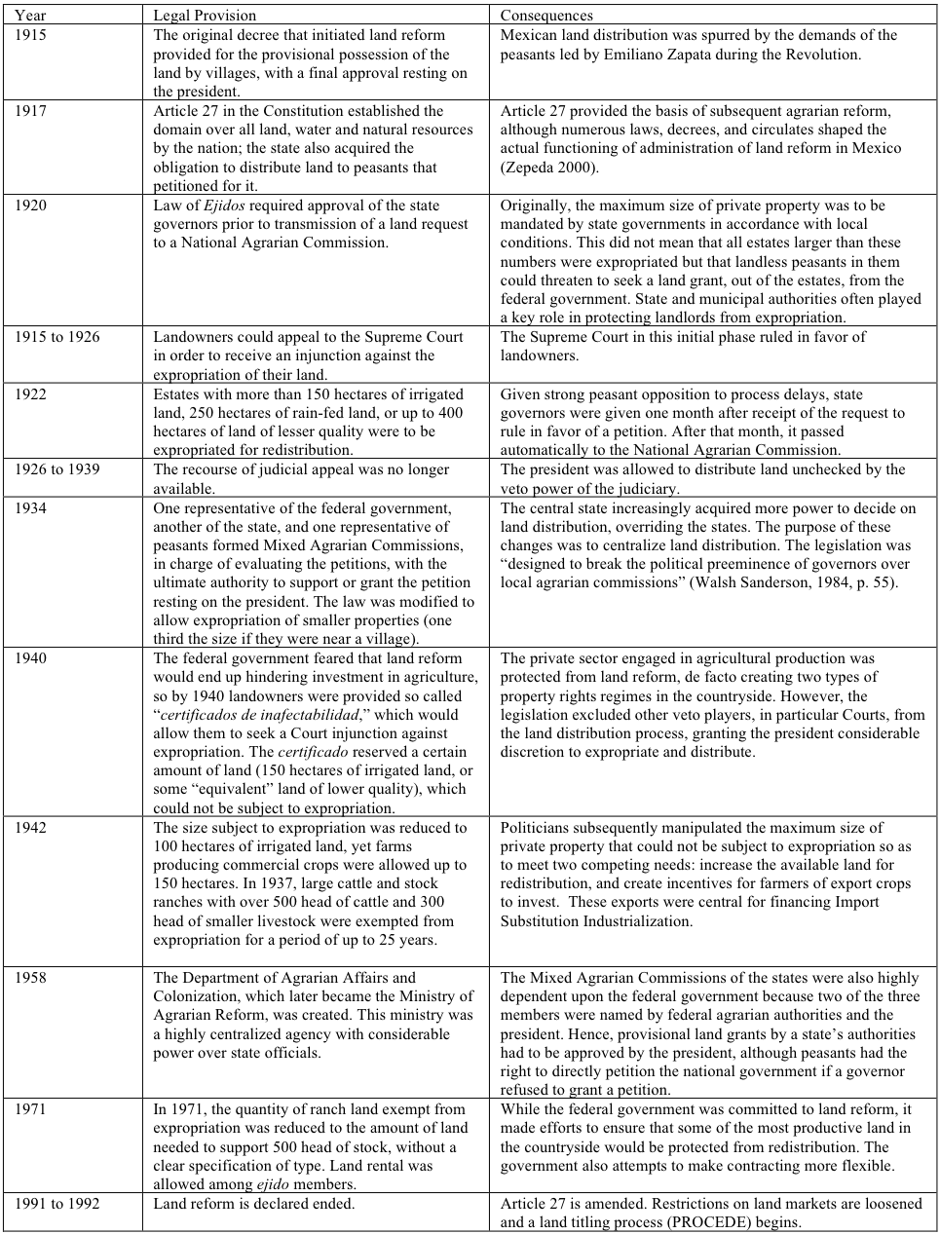
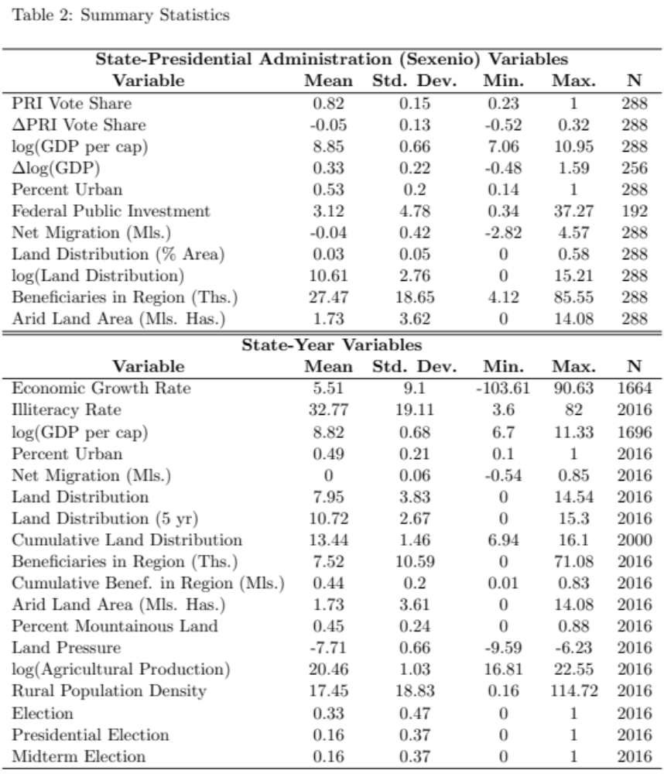

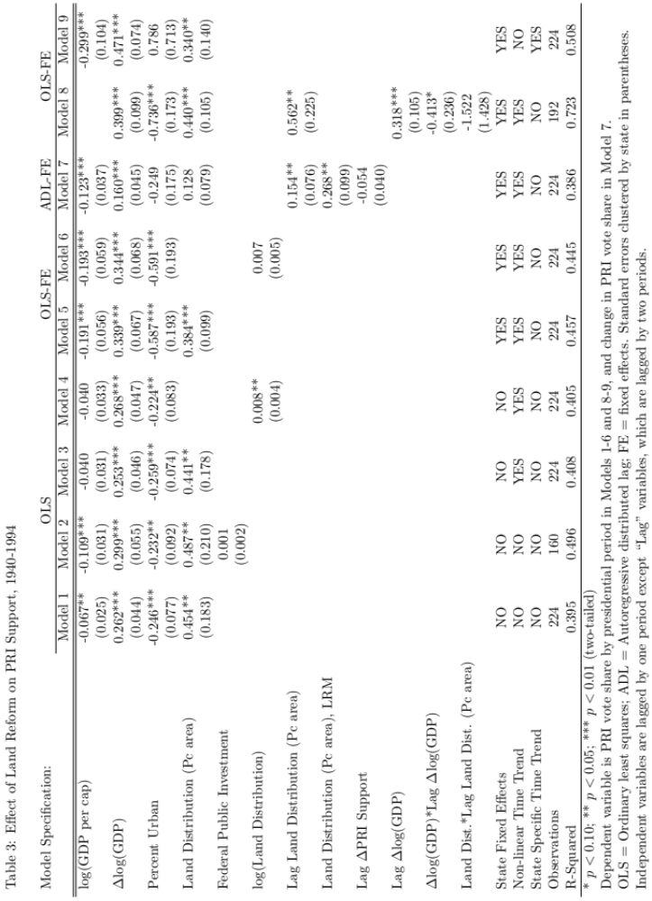
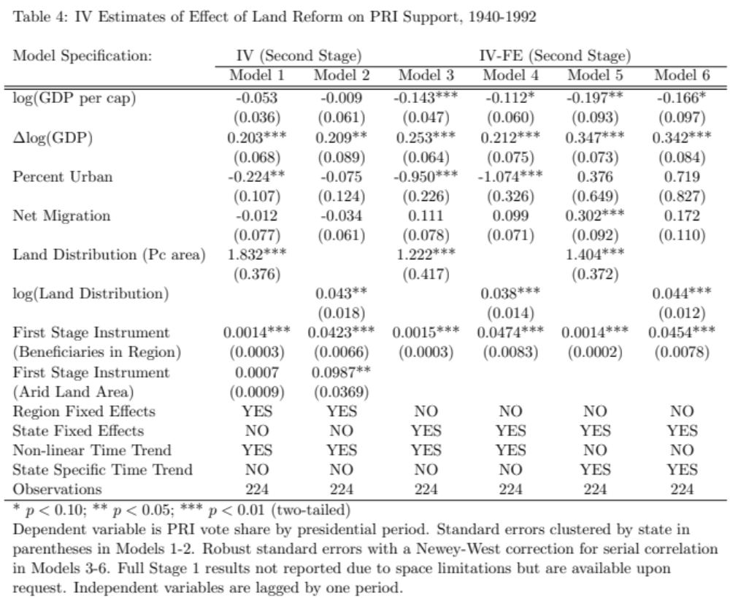

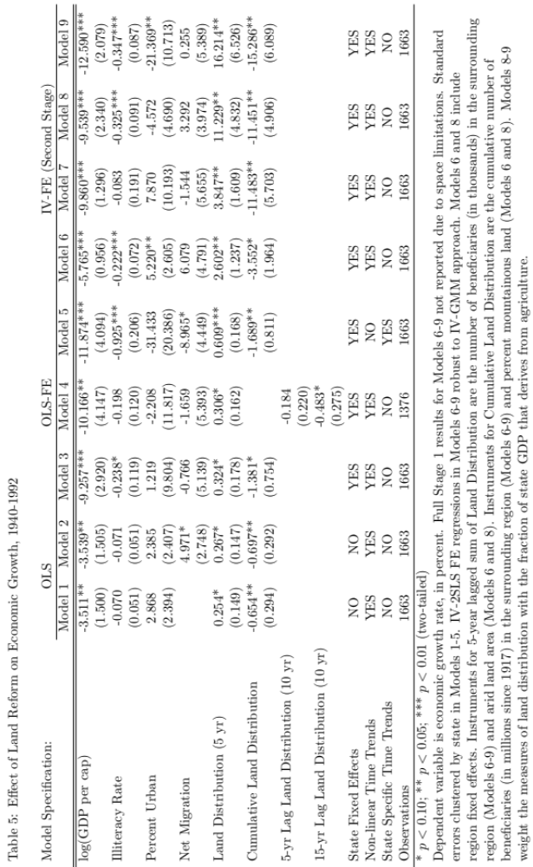
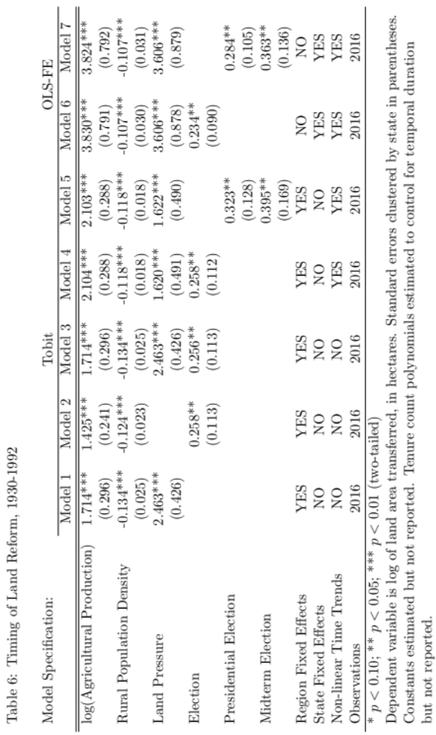

Table 7: Land Reform in Comparative Perspective
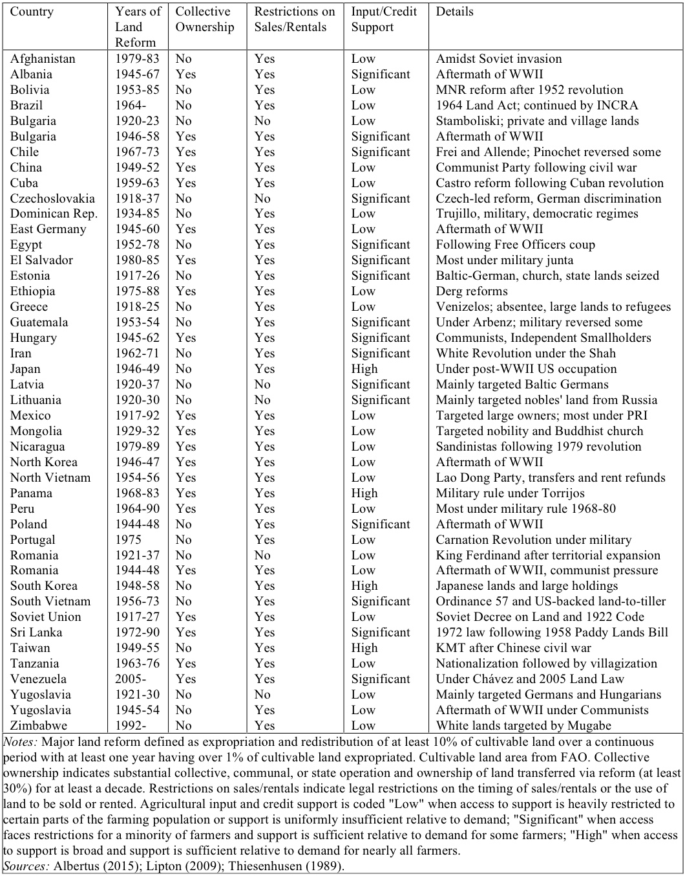
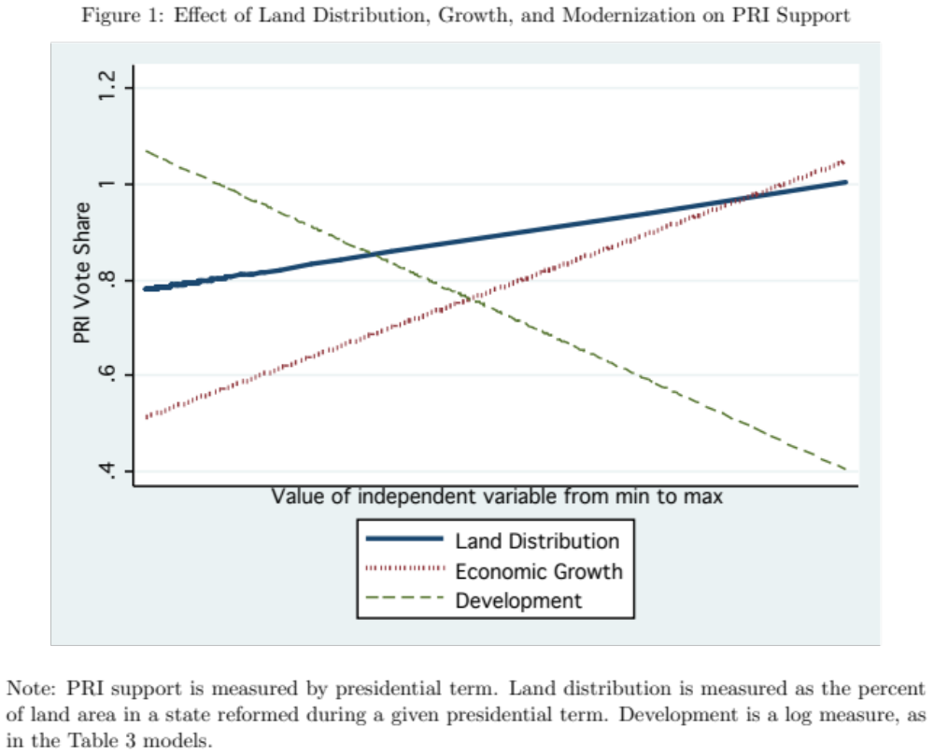

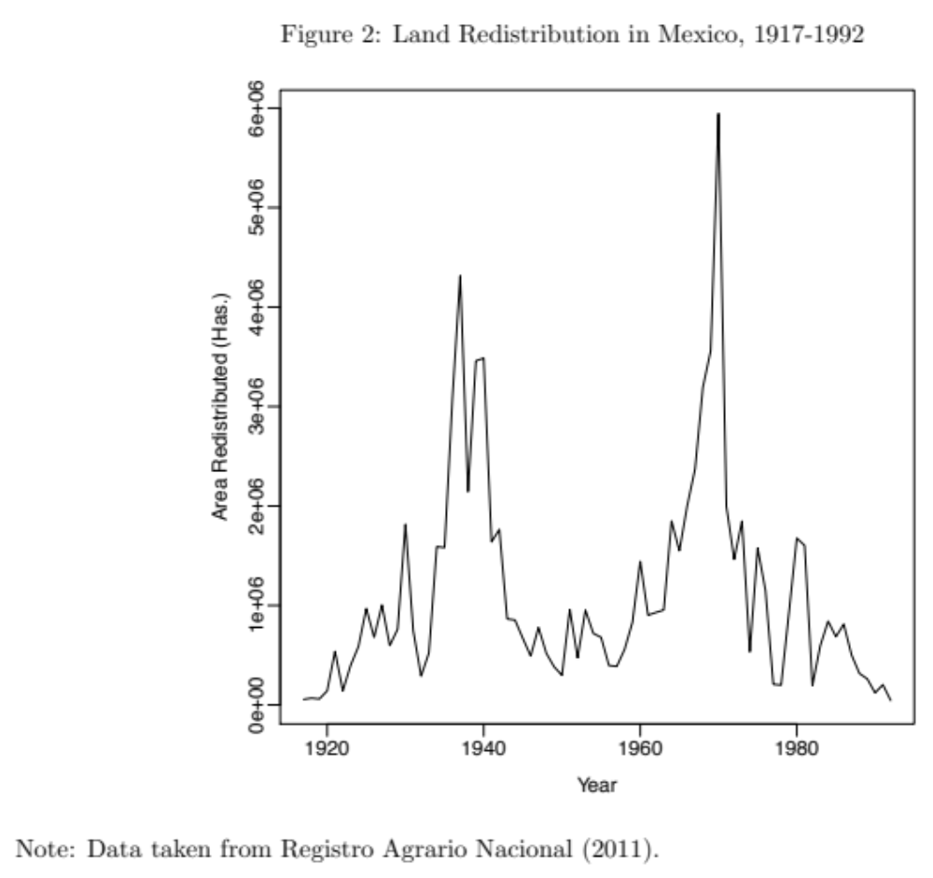

An extensive literature shows that peasants were a crucial base of support for the PRI. See, e.g., Ames (1970), Hansen (1971), and Kurtz (2004).
Indeed, when land reform ended in 1992 and the PRI began to grant complete property rights, many peasants defected to the challenger pro-market PAN (de Janvry et al. 2013).
“Collective” ejidos were typically created from highly productive haciendas in irrigated regions where the agrarian movement was intense (Otero 1989, 283).
Contra Alesina and Rodrik (1994), land reform in Mexico did not help to mobilize savings and investment in the ejido sector, a point we develop in the section below.
These hacienda owners were not typically political elites under the PRI. The only significant landowning group to take a seat of political power under the PRI was northern landowners. These landowners avoided the early stages of significant land reform, and when reform finally came to the north, national political elites often selectively avoided losing their property. While land reform had distributional economic implications for key PRI political elites, it rarely targeted their personal landholdings.
For instance, Mexico’s 1988 national agrarian survey (Encuesta nacional agropecuaria ejidal) demonstrates overwhelming support for continued land redistribution.
Most authors describe these characteristics as natural imperatives arising from peasant demands for social justice.
In practice, of course, regimes can choose "mixed strategies" incorporating elements of each.
This does not imply that the “Mexican miracle” of economic growth did not occur, nor that the PRI sought to avoid growth. Instead, we argue that the PRI faced less of a political tradeoff in pursuing land reform relative to economic growth over the long term. Our argument implies that some states – those where the stock of reformed land was lower – should have benefitted from the “Mexican miracle” more than others.
Evidence suggests that peasants were able to evade some of these restrictions. For example, many who migrated informally rented their lands.
Because the collective nature of holdings along with severe restrictions on the sale and rental of land was coterminous with the under-provision of agricultural inputs and credits, our analyses cannot tell us whether the nature of ejido holdings was the only feature accounting for relatively lower growth, but rather whether the coterminous set of features detailed here together served to slow long-term growth.
Indeed, even by the mid-1990s, less than half of ejidos employed any modern technology (Thiesenhusen 1995).
This could also have garnered greater short-term support from peasants, though the modernization effect would likely have kicked in more quickly, eroding the support base of the party as it did in South Korea and Taiwan.
While it would be ideal to have a more disaggregated unit of analysis, data on critical variables such as GDP per capita, economic growth, and PRI support are not available at lower levels of aggregation for a considerable historical time period. These and subsequent analyses therefore focus on the state level.
This is consistent with Kurtz (2004), who uses post-1991 municipal-level data to show that peasants tended to support the PRI, and with the more recent individual-level findings of the public opinion literature.
The supplementary appendix includes a codebook of variable coding and sources.
We also tested controls for education and migration. Education could reduce PRI support and, when omitted, potentially bias downward the log per capita GDP variable in favor of our hypothesis. Immigration into a state could be tied to land reform activity and also a more positive (or negative) view of the PRI. Both variables were almost always statistically insignificant and never affected our conclusions.
The scale for economic growth excludes one outlier for high growth; the Table 3 results are nonetheless robust to its exclusion.
See Walsh Sanderson (1984) for a discussion on the delays in land grant deliveries.
Staiger and Stock (1997) argue that F-tests from the first-stage should be greater than 10.
A Hansen J test returns a chi-square of 0.226 with a p-value of 0.63 in Model 1 and a chi-square of 1.505 with a p-value of 0.22 in Model 2.
We focus on this measure here and in subsequent analyses over measures normalized by state area given that the latter may distort the perceived degree of reform (e.g., by recording a lower portion of land reformed in a large, sparsely populated state compared to a smaller, similarly populated state that receives the same amount of land distribution). We instead directly control for factors that may impact the importance of land distribution and use state fixed effects.
See the supplementary appendix for graphs of yearly land distribution by state.
Additional lags point to a similar trend, though the observations begin to decline substantially.
IV estimations building from the Model 4 and Model 5 specifications also yield similar results.
A Hansen J test yields a chi-square of 2.952 with a p-value of 0.23 in Model 6.
This is also true at the state level for most Mexican states; see the supplementary appendix.
A series of unconditional fixed effects tobit models that used indicator variables for the panels yielded largely similar results, but are not included given bias concerns in these models.
We also tested a control for economic growth, which had no measurable impact.
Major land reform is defined as redistribution of at least 10% of cultivable land with at least one year having over 1% of cultivable land expropriated. This criteria eliminates several reforms that were either small relative to country size or characterized mainly by negotiated transfers or colonization of state-owned land (e.g., Colombia, India, the Philippines, and South Africa). See Table 7 notes for coding land reform characteristics.

